Unidirectional

🔄 What Is Unidirectional Network Traffic?
# Source: AI Source: Provided by: [Data Path: Persons Table -> ID Column: 1, Name_En Column: Motasem Essam] -> From: [ChatGPT] on [12/9/2025]
Unidirectional traffic refers to data that flows in one direction only — from a source to a destination, without expecting a response. This type of traffic is common in monitoring, streaming, logging, and certain types of sensor or control systems.

🧠 Simple Definition:
# Source: AI Source: Provided by: [Data Path: Persons Table -> ID Column: 1, Name_En Column: Motasem Essam] -> From: [ChatGPT] on [12/9/2025]
Unidirectional traffic is a one-way flow of data where only the sender transmits and the receiver does not reply.

📡 Real-World Examples
# Source: AI Source: Provided by: [Data Path: Persons Table -> ID Column: 1, Name_En Column: Motasem Essam] -> From: [ChatGPT] on [12/9/2025]
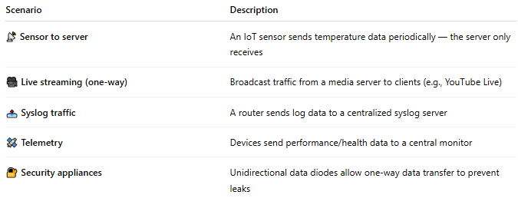

Scenario | Description
📡 Sensor to server | An IoT sensor sends temperature data periodically — the server only receives
🎥 Live streaming (one-way) | Broadcast traffic from a media server to clients (e.g., YouTube Live)
📤 Syslog traffic | A router sends log data to a centralized syslog server
🛰 Telemetry | Devices send performance/health data to a central monitor
🔐 Security appliances | Unidirectional data diodes allow one-way data transfer to prevent leaks

🔁 Comparison to Bidirectional Traffic
# Source: AI Source: Provided by: [Data Path: Persons Table -> ID Column: 1, Name_En Column: Motasem Essam] -> From: [ChatGPT] on [12/9/2025]
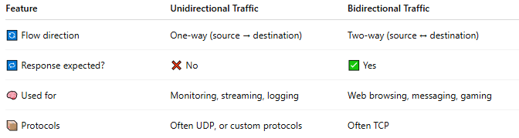

Feature | Unidirectional Traffic | Bidirectional Traffic
🔄 Flow direction | One-way (source → destination) | Two-way (source ↔ destination)
🔁 Response expected? | ❌ No | ✅ Yes
🧠 Used for | Monitoring, streaming, logging | Web browsing, messaging, gaming
📦 Protocols | Often UDP, or custom protocols | Often TCP

⚙️ Common Protocols for Unidirectional Traffic
# Source: AI Source: Provided by: [Data Path: Persons Table -> ID Column: 1, Name_En Column: Motasem Essam] -> From: [ChatGPT] on [12/9/2025]
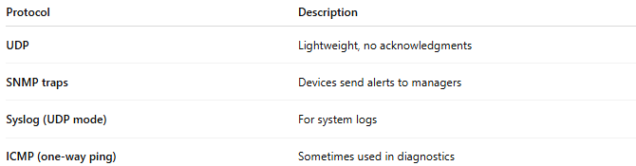

Protocol | Description
UDP | Lightweight, no acknowledgments
SNMP traps | Devices send alerts to managers
Syslog (UDP mode) | For system logs
ICMP (one-way ping) | Sometimes used in diagnostics

✅ Benefits of Unidirectional Traffic
# Source: AI Source: Provided by: [Data Path: Persons Table -> ID Column: 1, Name_En Column: Motasem Essam] -> From: [ChatGPT] on [12/9/2025]
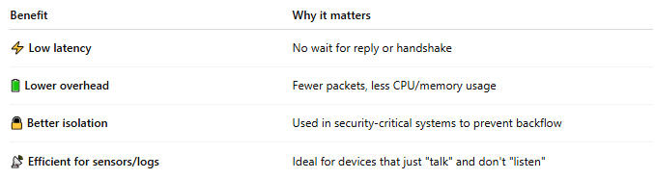

Benefit | Why it matters
⚡ Low latency | No wait for reply or handshake
🔋 Lower overhead | Fewer packets, less CPU/memory usage
🔒 Better isolation | Used in security-critical systems to prevent backflow
📡 Efficient for sensors/logs | Ideal for devices that just "talk" and don't "listen"

⚠️ Limitations
# Source: AI Source: Provided by: [Data Path: Persons Table -> ID Column: 1, Name_En Column: Motasem Essam] -> From: [ChatGPT] on [12/9/2025]
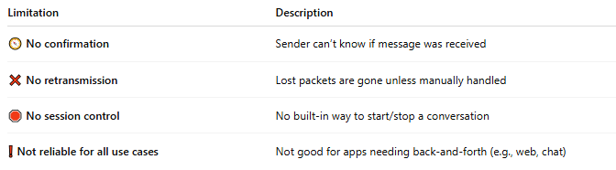

Limitation | Description
🧭 No confirmation | Sender can’t know if message was received
❌ No retransmission | Lost packets are gone unless manually handled
🛑 No session control | No built-in way to start/stop a conversation
❗ Not reliable for all use cases | Not good for apps needing back-and-forth (e.g., web, chat)

📌 Summary
# Source: AI Source: Provided by: [Data Path: Persons Table -> ID Column: 1, Name_En Column: Motasem Essam] -> From: [ChatGPT] on [12/9/2025]
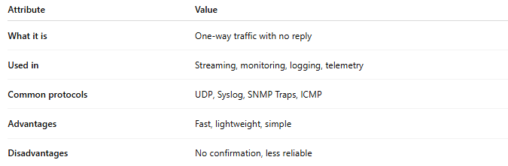

Attribute | Value
What it is | One-way traffic with no reply
Used in | Streaming, monitoring, logging, telemetry
Common protocols | UDP, Syslog, SNMP Traps, ICMP
Advantages | Fast, lightweight, simple
Disadvantages | No confirmation, less reliable

